 | Registration Form
  South-West University  "Neofit Rilski" | SCIENTIFIC CONFERENCE  WITH INTERNATIONAL PARTICIPATION  Linguistics: History, Challenges, Perspectives  21 – 22 June 2018, Blagoevgrad  SWU “Neofit Rilski” | 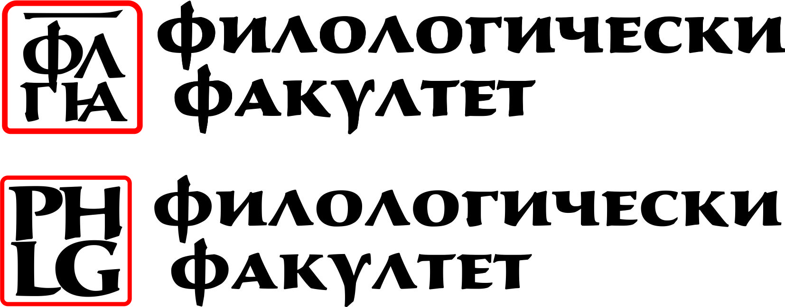  Faculty of Philology  http://philology.swu.bg/  Department of Bulgarian Language

First Name: _______________________________________________
Last Name: ___________________________________________ (as it will appear on the badge)
Organization / University: ___________________________________________________________________________________
Preferred Mailing Address: __________________________________________________________________________________
City: ______________________________ State/Province: ______________________ Zip/Postal Code: _________________
Country: ___________________________ Telephone: (______)__________________ Fax: (______)____________________
E-mail: ____________________________________

Title ………………………………………………………………………………………………………………………..
Abstract (200 words)
................................................................................................................................................................................................................................................................................................................................................................................
................................................................................................................................................................................................................................................................................................................................................................................
................................................................................................................................................................................................................................................................................................................................................................................

I. CONFERENCE FEES:
- Registration Fees (All fees listed in Euros.) Included in the price:
Conference materials, conference proceedings, certificate of participation/ attendance, coffee breaks.

Please, tick which applies to you: | registration fee
Professionals | ❒ 25 €
Distant participation | ❒ 20 €
Students, PhD students | ❒ 15 €

* Fees may be paid onsite on 21 June 2018 until 17.00 h
* Participants who need an invoice have to pay by bank transfer until 1 June 2018

BANK DETAILS: | Mailing address:
Beneficiary: South-West University “NEOFIT Rilski”  Bank: MUNICIPAL BANK  Accounts: EUR: BG 97SOMB91303460613000  BGN BG62SOMB 9130 31 60613000  BIC: SOMBBGSF  Basis for payment:  Conference in Linguistics - ……. (Name/s of participant/s). | SOUTH-WEST UNIVERSITY “NEOFIT RILSKI”  Department of Bulgarian Language  66 Ivan Mihailov Street,  2700 Blagoevgrad, Bulgaria  Fax: +359-73-88 55  Email: lingvistika@swu.bg

3. Dates to remember:
Abstract submission (up to 200 words) – 01 May 2018
Notification of acceptance – 15 May 2018
Full paper submission – Deadline: 01 November 2018

Organization committee:

Associate Prof. L. Perchekliyski, PhD
Associate Prof. G. Padareva-Ilieva, PhD
Associate Prof. Radoslav Tsonev, PhD
Assistant Prof. Bilyana Todorova, PhD
Assistant Prof. Sofia Mitsova, PhD
Assist. Prof. Krasimira Hadzhieva, PhD

