 | Registration Form
  South-West University  "Neofit Rilski" | IV SCIENTIFIC CONFERENCE  WITH INTERNATIONAL PARTICIPATION  Linguistics: History, Challenges, Perspectives  1 – 2 June 2023, Blagoevgrad  SWU “Neofit Rilski” | 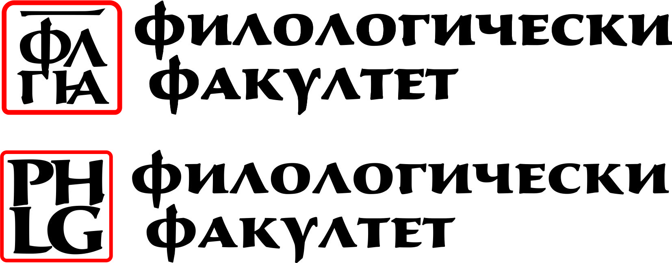  Faculty of Philology  http://philology.swu.bg/  Department of Bulgarian Language

First Name: _______________________________________________
Last Name: ___________________________________________ (as it will appear on the badge)
Organization / University: ___________________________________________________________________________________
Preferred Mailing Address: __________________________________________________________________________________
City: ______________________________ State/Province: ______________________ Zip/Postal Code: _________________
Country: ___________________________ Telephone: (______)__________________
E-mail: ____________________________________

Title ………………………………………………………………………………………………………………………..
Abstract (200 words)
................................................................................................................................................................................................................................................................................................................................................................................
................................................................................................................................................................................................................................................................................................................................................................................
................................................................................................................................................................................................................................................................................................................................................................................

I. CONFERENCE FEES:
- Registration Fees (All fees listed in Euros.) Included in the price:
Conference materials, conference proceedings “Linguistic Problems” 3, certificate of participation/ attendance, coffee breaks.

Please, tick which applies to you: | registration fee
Professionals | ❒ 30 €
Distant participation | ❒ 25 €
Students, PhD students | ❒ 15 €

* Fees may be paid onsite on 1 June 2023 until 17.00 h
* Participants who need an invoice have to pay by bank transfer until 25 May 2023

BANK DETAILS: | Mailing address:
Beneficiary: South-West University “NEOFIT Rilski”  Bank: MUNICIPAL BANK  Accounts: EUR: BG 97SOMB91303460613000  BGN BG62SOMB 9130 31 60613000  BIC: SOMBBGSF  Basis for payment:  Conference in Linguistics: ……. (Name/s of participant/s). | SOUTH-WEST UNIVERSITY “NEOFIT RILSKI”  Department of Bulgarian Language  66 Ivan Mihailov Street,  2700 Blagoevgrad, Bulgaria  Fax: +359-73-88 55  Email: lingvistika@swu.bg

3. Dates to remember:
Abstract submission (up to 200 words) – 01 May 2023
Notification of acceptance – 15 May 2023
Full paper submission – Deadline: 20 June 2023

Organization committee:

Associate Prof. L. Perchekliyski, PhD
Associate Prof. G. Padareva-Ilieva, PhD
Associate Prof. Radoslav Tsonev, PhD
Associate Prof. Bilyana Todorova, PhD
Associate Prof. Borislav Popov PhD
Assistant Prof. Lyubka Nenova. PhD
Assistant Prof. Krasimira Hadzhieva, PhD
Assistant Prof. Nadelina Ivova, PhD
Assistant Prof. Sofia Mitsova, PhD
Assistant Prof. Milena Nakova-Petrova, PhD

